Secure Result and Automated Query Resolution System

Bachelor of Technology
in
COMPUTER ENGINEERING

M. V. Sai Deepthi (12213083)
Pastam Rahul (12213094)
Rohit Kumar (12213101)

Under the Supervision of

Dr. Punit Kumar
Assistant Professor

Department of Computer Engineering
National Institute of Technology, Kurukshetra
Haryana-136119, India

Nov 2025

CERTIFICATE

We hereby certify that the work presented in this B.Tech Project report, entitled “Secure Result and Automated Query Resolution System”, in partial fulfillment of the requirements for the End-Semester evaluation of the Bachelor of Technology (Information Technology) program, is an authentic record of our own work carried out from August 2025 to November 2025, under the supervision of Dr. Punit Kumar, Assistant Professor, Department of Computer Engineering, National Institute of Technology, Kurukshetra, India.
The matter presented in this project report has not been submitted for the award of any other degree elsewhere.

Signatures of Candidates
M. V. Sai Deepthi (12213083)
Pastam Rahul (12213094)
Rohit Kumar (12213101)
This is to certify that the above statement made by the candidates is correct to the best of my knowledge.

Date: 21.11.2025
Signature of Supervisor Faculty Mentor
Dr. Punit Kumar
(Assistant Professor)

ACKNOWLEDGEMENT

We would like to express our sincere gratitude to Dr. Punit Kumar, Assistant Professor, Department of Computer Engineering, National Institute of Technology, Kurukshetra, for his continuous guidance, encouragement, and valuable insights throughout the duration of this project. His constructive feedback and support have played a crucial role in shaping the direction and quality of our work.
We are thankful to the Department of Computer Engineering, NIT Kurukshetra, for providing the necessary resources, academic environment, and technical support required for the successful completion of this project.
We would also like to thank all faculty members and supporting staff of the department for their cooperation and assistance whenever needed.
Our heartfelt gratitude goes to our friends and classmates for their constant motivation, discussions, and support during various phases of the project.
Finally, we extend our deepest appreciation to our families for their unconditional support, patience, and encouragement, which enabled us to carry out this work with dedication and confidence.
M. V. Sai Deepthi (12213083)
Pastam Rahul (12213094)
Rohit Kumar (12213101)

ABSTRACT

The Secure and Automated Result Management and Query Resolution System is an innovative, AI-assisted platform developed to transform traditional, manual methods of handling academic results and student grievances into a more efficient, transparent, and automated digital workflow. In many educational institutions, result-related issues—such as marks discrepancies, missing grades, absentee errors, and clerical mistakes, are still processed manually, leading to delays, communication gaps, and increased administrative workload. This project addresses these limitations by integrating lightweight Machine Learning (ML) models, and a unified Streamlit-based user interface into a secure and scalable framework.
The system utilizes TF–IDF based text representation and a Multinomial Naive Bayes classifier to automatically categorize student complaints into predefined issue types, substantially reducing manual sorting time and improving institutional responsiveness. Additional functionalities include complaint submission and tracking, CSV-based result uploads, role-specific access for students and administrators, and interactive dashboard analytics. Developed fully in Python using Streamlit for the interface and SQLite for local data storage, the system achieves seamless integration of UI, business logic, and ML inference without the need for external APIs, microservices, or complex deployment pipelines.
Experimental evaluation conducted on synthetically generated complaint data demonstrates strong model performance, achieving an accuracy of approximately 86% for complaint classification. By automating repetitive operations and offering structured insights into complaint patterns and result data, the system significantly enhances operational efficiency, transparency, and user experience.
This work highlights the effectiveness of lightweight AI solutions and streamlined application design in improving academic governance. Future developments may include integration with real institutional datasets, multilingual complaint processing, continuous model retraining, and expanded analytics for deeper insights into student-related issues.
Keywords: Result Management System, Academic Dispute Resolution, Machine Learning, Complaint Classification, TF–IDF, Naive Bayes, Streamlit, SQLite, Educational Data Processing.

Table of Contents
CERTIFICATE 1
ACKNOWLEDGEMENT 2
ABSTRACT 3
List of Tables 6
List of Figures 7
1. Introduction 8
1.1 Background & Motivation 8
1.2 Problem Definition & Scope 8
1.3 Objectives of the Study 9
1.4 Functionalities 9
1.5 Constraints 10
2. Literature Review 10
2.1 Overview: 10
2.2 SLA-Driven Proactive Resource Management (Sehrish Nadeem, 2023) [1]: 11
2.3 Automated Complaint Classification: 11
2.4 Similar Complaint Detection: 11
2.5 SLA Prediction (Time-to-Resolution): 11
2.6 Anomaly Detection in Marks and Results Data: 11
2.7 Explainable AI (Cox Model Interpretability): 11
3. System Design & Architecture 12
3.1 High-Level Architecture 12
3.2 Module Description 13
3.3 Tech Stack 14
3.4 Data Model 15
3.5 Sequence Diagram: 16
4. Data & Preprocessing 17
4.1 Dataset Description 17
4.2 Data Splits 18
5. Machine Learning Models 18
5.1 Module-wise Model Design 19
5.2 Explainability 20
5.3 Training & Validation 20
6. Results 20
6.1 Overview 20
6.2 Complaint Type Classification Results 20
6.3 Similarity Detection Model: 22
6.4 SLA Prediction Results: 24
6.5 Anomaly Detection Results 25
6.6 UI Interface 28
7. Conclusion & Future Work 29
7.1 Conclusion 29
7.2 Future Scope 29
8 Bibliography 30
9 Real Project-Report Examples for Inspiration 30

List of Tables

Table 1 - Performance Metrics of Complaint Type Classification Model 21
Table 2 - Performance Metrics of S-BERT Model 23
Table 3 - Performance Metrics of SLA Prediction Model 24
Table 4: Complaint Categories in Dataset 26
Table 5: Performance metrics of Anomaly Detection Model 26

List of Figures
Figure 1 - System Architecture Diagram 12
Figure 2 - ER Diagram of the Database 15
Figure 3 - System Workflow Sequence Diagram 16
Figure 4 - Complaint Classification Benchmarking 22
Figure 5 - Similar Complaint Detection Benchmarking 23
Figure 6 - SLA Resolution Time Prediction Benchmarking 25
Figure 7 - Anomaly Detection Benchmarking 27
Figure 8 - Admin Dashboard 28

1. Introduction

1.1 Background & Motivation
The rapid digital transformation of academic institutions has significantly improved the efficiency of result management and communication systems. However, despite these advancements, result-related disputes such as marks mismatches, absentee errors, missing grades, and calculation discrepancies remain common. These issues, when handled manually, lead to administrative delays, lack of transparency, and student dissatisfaction. The absence of a systematic, data-driven approach to handling such complaints often causes communication gaps between students, faculty, and administrative bodies.
Traditional university result management systems primarily focus on record storage and retrieval, but not on intelligent dispute resolution or automated feedback generation. As the number of enrolled students increases, institutions face challenges in processing and resolving complaints promptly. Each query must be manually reviewed by faculty or administrative staff, resulting in extended turnaround times and inconsistent resolutions. The need for automation, security, and AI-based intelligence in academic grievance systems has therefore become increasingly vital.
This project, Secure Result and Automated Query Resolution System, is designed to address these limitations by integrating Artificial Intelligence (AI), Machine Learning (ML), and secure web technologies into a unified academic dispute management platform. The system automates complaint categorization, predicts SLA (Service Level Agreement) breach risks, identifies duplicate or similar complaints, and provides explainable AI insights for decision-makers. It not only enhances operational efficiency but also ensures fairness, accountability, and transparency in result-related communications.
The motivation behind this project lies in transforming conventional, manual academic grievance workflows into an intelligent, proactive, and SLA-aware automation framework. In contrast to Sehrish Nadeem’s (2023) SLA Management System for cloud environments [1], which emphasizes proactive monitoring and early detection of SLA violations through predictive analytics, our system adapts these principles to an academic context. While their work optimizes computational resources and prevents service breaches in cloud infrastructures, our research applies similar predictive and preventative strategies to student complaint handling—focusing on automated categorization, SLA-based delay risk prediction, and intelligent prioritization of academic grievances. This enables institutions to move beyond reactive processing and adopt a more efficient, AI-driven grievance management approach.
In essence, this project represents a significant step toward developing a smart academic governance system, one that transforms unstructured student complaints into actionable insights. It aligns with modern educational quality standards, reduces administrative workloads, and builds trust between students and institutions by ensuring data-driven, transparent, and secure resolution processes.

1.2 Problem Definition & Scope
Manual handling of academic result-related complaints is slow, inconsistent, and opaque. Students usually report issues such as marks mismatches, absentee errors, missing grades, or calculation mistakes through informal or paper-based channels. Faculty members then verify and process these cases individually, leading to long turnaround times, redundant work, and limited accountability. Because no automated classification or tracking exists, administrators must manually identify complaint types, assign priorities, and estimate resolution times. This manual workflow increases the likelihood of human error, loss of information, and dissatisfaction among students. Furthermore, institutions lack tools to predict Service Level Agreement (SLA) delays, detect duplicates, or analyze complaint patterns that could reveal systemic issues.

In contrast to Sehrish Nadeem’s (2023) SLA Management Framework [1], which focuses on proactively preventing service violations in cloud infrastructures through predictive monitoring and resource optimization, this project adapts similar SLA-driven principles for the academic grievance domain. Our system applies comparable predictive analytics to estimate complaint-resolution risks, enabling proactive intervention and more efficient academic administration.

1.3 Objectives of the Study
The primary objective of this project is to develop a secure, automated, and intelligent result management and query-resolution system that leverages lightweight Artificial Intelligence and Natural Language Processing techniques to streamline the handling of academic disputes. The system is designed to improve transparency, reduce administrative workload, and ensure timely, consistent, and data-driven resolution of student complaints.
A key goal of the system is automated query classification, achieved through the implementation of a text-based Machine Learning model that categorizes student complaints, such as marks mismatches, absentee errors, missing grades, or general academic issues, using TF–IDF feature extraction combined with a Naïve Bayes classifier. In addition, the system enables efficient complaint management by providing a unified platform where students can submit, track, and monitor complaints, while administrators can categorize, update, and resolve them through an integrated interface.
The project also focuses on streamlined result handling, allowing administrators to securely upload and manage student results using CSV imports, ensuring accurate and organized storage of academic records. To further enhance data reliability, the system incorporates anomaly detection using Machine Learning models such as Isolation Forest to identify irregularities or suspicious patterns in student results or complaint submissions.
Finally, the project aims to improve administrative decision-making through a comprehensive admin dashboard and explainability module, built using FastAPI. This dashboard provides visual analytics, statistical summaries, and Cox Proportional Hazards based explainable AI insights, enabling administrators to understand SLA-related risks and make informed, transparent decisions.

1.4 Functionalities
The system provides automated dispute classification through NLP-driven processing, where a TF–IDF and Naive Bayes based model categorizes student complaints into predefined classes, significantly reducing manual workload and accelerating grievance resolution. A secure, role-based web portal developed using Streamlit ensures that students and administrators access only the functionalities relevant to their roles, thereby maintaining data confidentiality and controlled interaction with the system. Students can submit new complaints, track their status, and review historical records, while administrators are equipped with tools to review, update, and manage complaints efficiently through an organized dashboard interface.
In addition to complaint handling, the platform supports secure result upload and management, allowing administrators to maintain accurate academic records. The system incorporates Cox Proportional Hazards–based interpretability features that provide insight into how SLA risks and resolution times are assessed, thereby enhancing transparency and trust in AI-driven decisions. Dashboard visualizations offer interactive summaries, category-wise distributions, and recent activity logs to facilitate informed administrative decision-making. Furthermore, the machine learning module includes explainability components such as confidence scores and highlight-based term importance, enabling users to understand the reasoning behind automated predictions and improving the system’s overall usability and accountability.

1.5 Constraints
The effectiveness of the classification, prediction, and anomaly detection models is strongly influenced by the availability and quality of labeled academic complaint datasets, as insufficient or imbalanced data can negatively impact model accuracy and generalization. Additionally, real-time updates and processing capabilities may face limitations arising from server load, computational constraints, and network latency, especially during periods of high user activity. The successful deployment of the system also depends on its ability to integrate seamlessly with existing institutional result portals or ERP platforms, which may necessitate the development of custom APIs or middleware to ensure compatibility with the current infrastructure.
1.6 Assumptions
User accessibility assumes that all stakeholders,including students, faculty, and administrators—possess stable internet connectivity and sufficient familiarity with web-based portals to interact effectively with the system. In terms of data privacy, the system operates under the assumption that institutional policies adhere to established data protection norms and GDPR like standards, ensuring secure management of sensitive academic information. Successful long-term functioning of the platform also depends on administrative adoption, presuming that institutional authorities will actively support the system by maintaining updated records, overseeing routine monitoring, and conducting periodic model retraining to preserve accuracy and reliability.

2. Literature Review

2.1 Overview:
Academic dispute and query management has been an area of growing interest, particularly as institutions seek to improve transparency, accountability, and responsiveness in handling student complaints. Traditional systems have primarily relied on manual processes, such as paper-based forms or email correspondence, where students raise queries regarding result discrepancies and faculty members respond on a case-by-case basis. While simple to implement, these approaches are inefficient, slow, and prone to data loss or miscommunication.
In contrast, SLA-driven service management frameworks, such as the proactive resource provisioning model proposed by Sehrish Nadeem (2023) [1] introduce structured mechanisms for monitoring service behavior, predicting SLA violations, and triggering timely interventions. Although developed for cloud infrastructure reliability, this framework emphasizes systematic threshold-based alerts, violation prediction, and automated response strategies, principles that can be effectively adapted to the academic domain for managing result-related grievances.
Recent advancements in Artificial Intelligence (AI) have led to the development of AI-driven ticketing and complaint management systems, which automate categorization, routing, and prioritization of service requests. These systems leverage Machine Learning and Natural Language Processing (NLP) to interpret unstructured complaint text, enabling efficient query handling and faster response times.
Furthermore, SLA (Service Level Agreement) prediction models have been explored in IT service management and customer support to estimate resolution delays and optimize workload distribution. Similarly, anomaly detection algorithms are widely used in structured datasets to identify irregularities that may indicate data errors or systemic inefficiencies. Finally, the rise of Explainable AI ensures that automated decisions in administrative systems remain interpretable, allowing decision-makers to understand the rationale behind AI-driven predictions and maintain accountability.

2.2 SLA-Driven Proactive Resource Management (Sehrish Nadeem, 2023) [1]:
Nadeem and colleagues introduced a cloud-oriented framework based on continuous SLA monitoring, predictive violation detection, and proactive resource provisioning to prevent service degradation. Their model demonstrated measurable benefits such as reduced SLA breaches, improved system responsiveness, and more efficient resource utilization.

2.3 Automated Complaint Classification:
The system uses TF–IDF vectorization with a machine-learning classifier to categorize student complaints into predefined types. This approach is lightweight, fast, and effective for structured academic complaint data.

2.4 Similar Complaint Detection:
Sentence-BERT embeddings are used to detect semantically similar or duplicate complaints by comparing vector similarities. This allows administrators to reuse past resolutions and avoid processing repeated issues.

2.5 SLA Prediction (Time-to-Resolution):
Studies on service management employ Cox Proportional Hazards Models and Random Survival Forests to predict the time until a service ticket is resolved. These survival-analysis techniques assess risk factors influencing delays.

2.6 Anomaly Detection in Marks and Results Data:
Anomaly detection research leverages methods such as Isolation Forest and statistical rule-based analysis to identify irregular or suspicious data patterns.

2.7 Explainable AI (Cox Model Interpretability):
Explainability in the proposed system is achieved through the Cox Proportional Hazards model, which provides a mathematically interpretable understanding of how various factors influence SLA resolution time and breach risk. This analytical interpretability allows administrators to clearly see which complaint types or departmental attributes contribute most to SLA violations, thereby enhancing trust, accountability, and confidence in the AI-driven decision-making process.

3. System Design & Architecture

3.1 High-Level Architecture

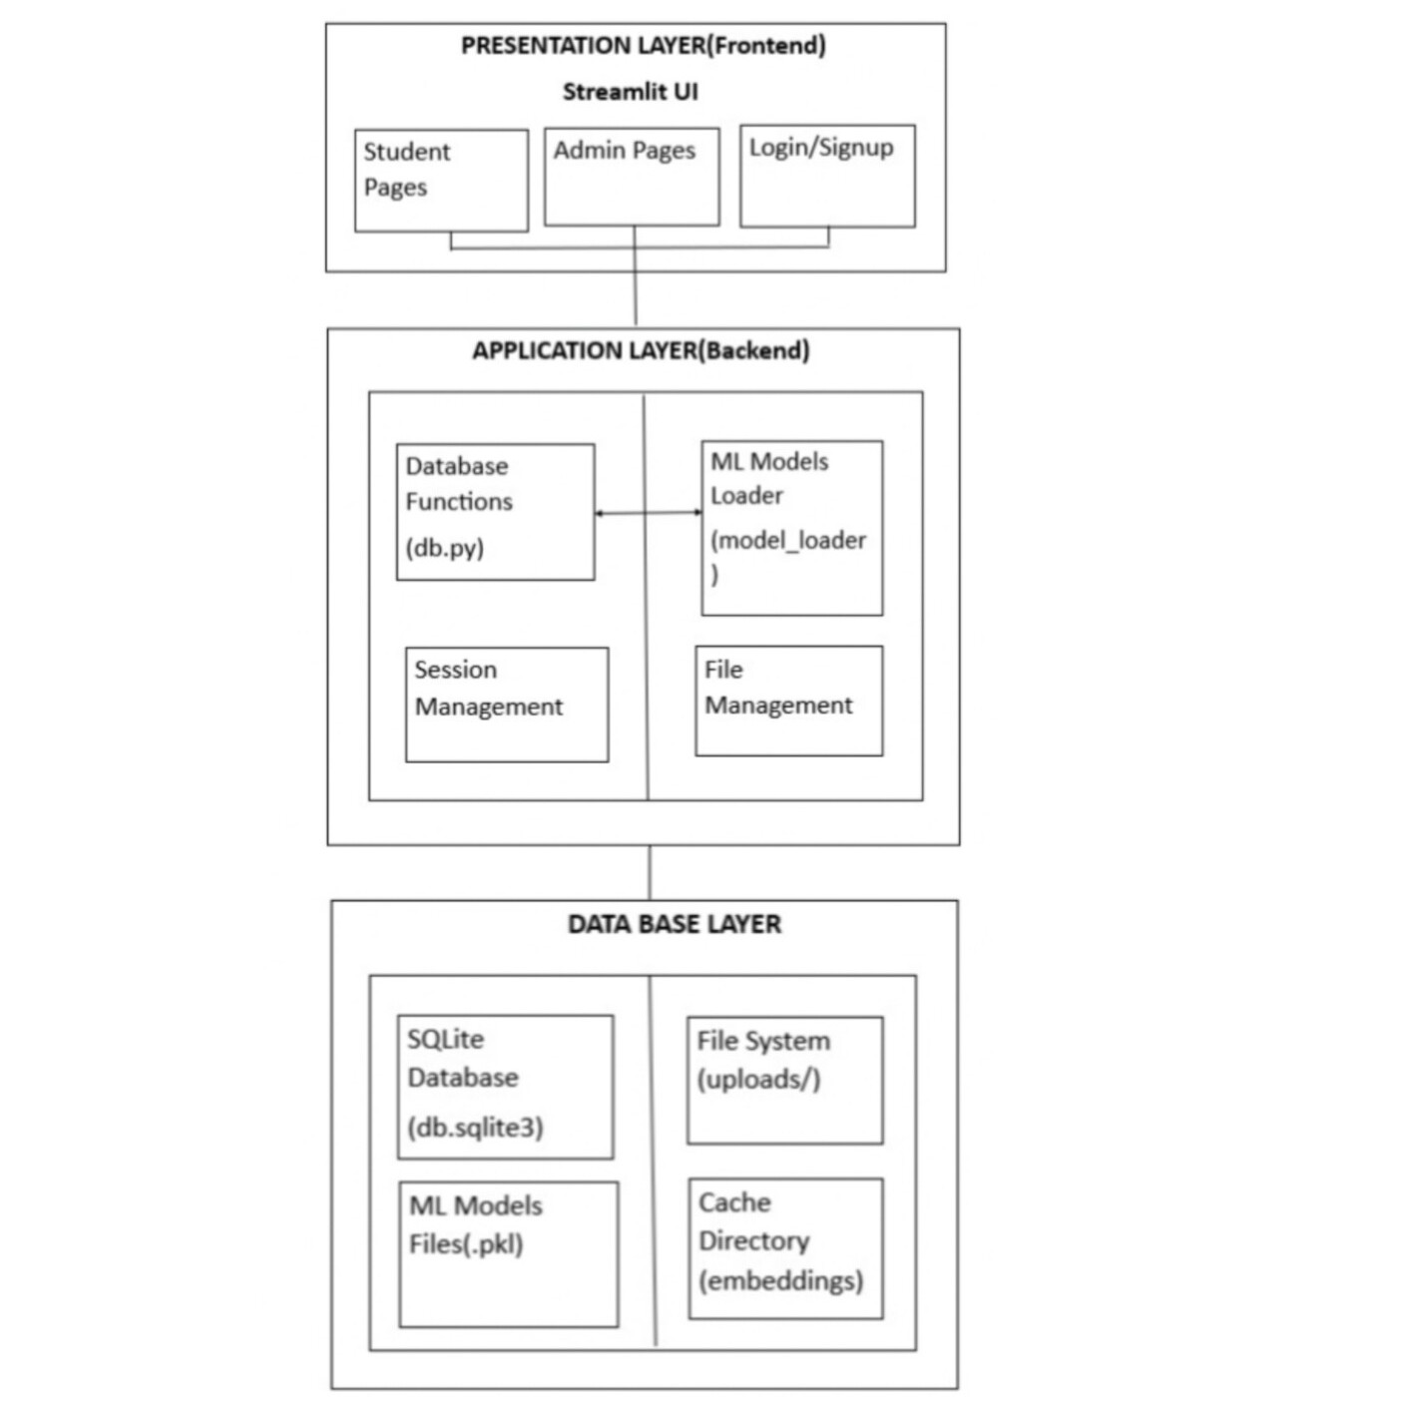

Figure 1 - System Architecture Diagram
The system is designed for scalability, transparency, and interoperability with institutional databases.

3.2 Module Description
The Secure Result and Automated Query Resolution System is organized into modular components to ensure clarity, maintainability, and ease of integration. Each module performs a specific role, and all communication occurs internally within the Python application through function calls.
Machine Learning Module
The Machine Learning module is responsible for all AI-driven prediction and analytical capabilities within the system, implemented using Python, Scikit-learn, and traditional text-processing pipelines. Its core functions include automated classification of complaint text using TF–IDF representations in combination with a Multinomial Naive Bayes classifier, generation of confidence scores, and extraction of key contributing terms to enhance interpretability. The module also supports batch processing, enabling administrators to upload CSV files for large-scale complaint classification and analysis. This component is seamlessly integrated into the Streamlit backend through internal Python function calls, ensuring a smooth and efficient interaction between the user interface and underlying ML processes.
Backend Module
The backend module, implemented in Python, is responsible for managing the system’s operational logic, data flow, and user interactions. Streamlit serves as the execution framework through which all backend processes are orchestrated, enabling seamless integration between interface components and server-side functionality. The backend handles essential system functions, including user authentication, session management, and role-based access control to ensure secure and structured usage. It processes complaint submissions, result uploads, and administrative actions while coordinating communication between the user interface, database operations, and machine learning components. This tightly coupled backend design ensures reliable performance and consistent execution of all system workflows.
Frontend Module
The user interface is developed entirely using Streamlit, providing an interactive, responsive, and user friendly environment for both students and administrators. It facilitates student side functionalities such as complaint submission, status tracking, and result viewing, ensuring seamless access to academic services. For administrators, the interface offers comprehensive dashboards, complaint management tools, and access to model generated insights to support effective decision making. Streamlit’s built-in widget also includes forms, tables, charts, and file upload components that enable dynamic interaction with system features while maintaining an intuitive and streamlined user experience.
Database & Storage Module
The system employs SQLite as its primary data storage backend, complemented by the local file system for managing model artifacts and CSV uploads. SQLite provides a lightweight yet reliable database solution, enabling structured storage of users, complaints, academic results, and prediction outputs with minimal configuration overhead. The module ensures efficient local data access and seamless integration with backend processes. Additionally, machine learning model artifacts stored in .pkl format are loaded directly from the local file system, allowing the system to execute predictions and analytics without external dependencies.
Database & Storage Module
The system employs SQLite as a lightweight, serverless relational database to securely manage all institutional data. Its seamless integration with Python and support for ACID-compliant transactions make it well suited for academic-scale applications and standalone deployments. SQLite provides reliable data integrity, minimal configuration requirements, and efficient local storage operations, thereby ensuring smooth interaction between the backend, machine learning components, and user interface.
Scheduler Module
The prototype does not require a dedicated scheduler.All tasks such as prediction, data processing, and result updates run on-demand within Streamlit.

3.3 Tech Stack

- Frontend: Streamlit
Used for building a responsive and modular user interface. Streamlit enables rapid UI development directly in Python, eliminating the need for separate frontend frameworks. Its interactive components and fast rendering enhance usability for both student and admin dashboards.
- Backend: Python
Python serves as the primary backend environment, handling all request processing, application logic, and machine-learning inference. By integrating backend logic directly within the Streamlit framework, the system achieves simplified architecture and seamless communication between UI elements and processing modules.
- ML Services: Python (Scikit-learn: TF-IDF and Naive Bayes)
Python powers all machine learning modules.

TF-IDF Vectorizer: Generates numerical feature representations of complaint text
Multinomial Naive Bayes: Performs automated complaint classification with fast and efficient inference suitable for real-time usage.
This combination provides lightweight and reliable classification performance within the application.
- Database: SQLite
Provides a lightweight, serverless relational database for secure storage of users, complaints, and result records. SQLite offers ACID compliant transactions and integrates smoothly with Python, making it ideal for local academic deployments.
- Task Handling: On-Demand Execution
All processing operations such as model loading, complaint classification, and result updates are executed on-demand within the Streamlit application. No external schedulers are required, ensuring simplicity and maintainability.
- Storage: Local File System
Used for secure storage of model files, database files, and generated outputs. This removes the dependency on external cloud storage services while ensuring fast and reliable offline access.

3.4 Data Model
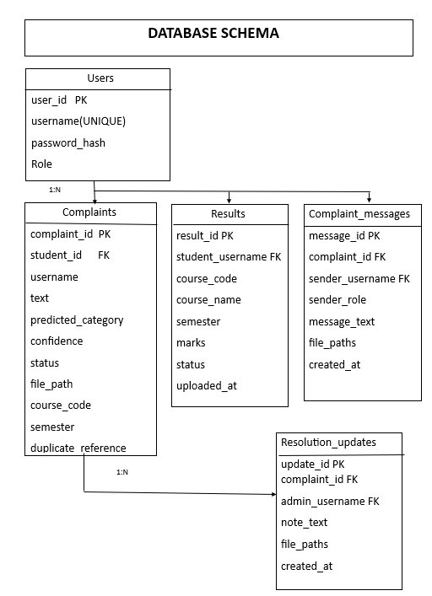

Figure 2 - ER Diagram of the Database

The diagram illustrates the core data entities of the Secure Result System, showing how user complaints, SLA records, logs, and attachments are interlinked.

3.5 Sequence Diagram:
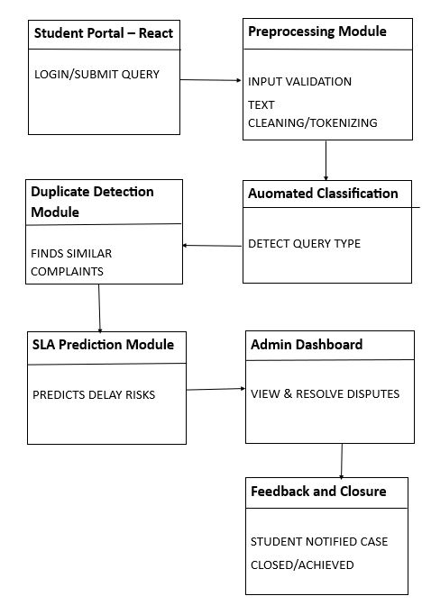

Figure 3 - System Workflow Sequence Diagram

4. Data & Preprocessing

4.1 Dataset Description
The primary dataset used in this project is titled “Student Complaints and Query Records”. It consists of synthetically generated data that simulates academic result-related complaints raised by students and managed by faculty or administrative staff. This dataset serves as the foundation for training and evaluating the AI/ML models used in automated classification, SLA risk prediction, and duplicate detection.
The dataset consists of approximately 1,000 records containing a mixture of structured categorical attributes, numerical variables, and textual complaint descriptions. This heterogeneous data composition supports comprehensive analysis across multiple machine learning tasks, including classification, anomaly detection, and SLA prediction.
4.1.1 Dataset Descriptions:
The project utilizes 2 datasets for machine learning model training and data management.
complaints.csv: This dataset contains historical complaint records used for training the complaint category classification model and duplicate detection system.
- Complaint ID: Unique identifier for each complaint record.
- Complaint Type: Categorical classification of complaint (Marks Mismatch, Absentee Error, Missing Grade, Calculation Discrepancy).
- Complaint Text: Full text description of the complaint submitted by the student.
- Complaint Status: Current status of the complaint (Pending, In Progress, Resolved, Rejected).
- Complaint Resolution Time: Number of days taken to resolve the complaint.
- Student ID: Unique identifier for the student who submitted the complaint.
- Student Program: Academic program or course of study of the student.
- Student Year: Academic year or semester level of the student.
- Faculty ID: Unique identifier for the faculty member handling the complaint.
- Faculty Department: Department name where the faculty member belongs.
- Predicted Complaint Type: ML model predicted category for the complaint.
- Predicted Priority: ML model predicted priority level for the complaint.
- Duplicate Flag: Boolean flag indicating if the complaint is a duplicate.
- SLA Risk Score: Numerical score indicating the risk of SLA breach.
- Recommended Action: Suggested action based on ML model analysis.
- Anomaly Flag: Boolean flag indicating if the complaint is an anomaly.
Explanation: Text explanation for anomaly detection or model predictions.
resolved_complaints.csv: This dataset contains resolved complaint records with additional resolution details, used for training the SLA prediction model and duplicate detection system.

- Complaint ID: Unique identifier for each resolved complaint record.
- Complaint Type: Categorical classification of the resolved complaint.
- Complaint Text: Original text description of the complaint.
- Complaint Status: Final status of the complaint (typically "Resolved").
- Complaint Resolution Time:| Actual number of days taken to resolve the complaint.
- Student ID: Unique identifier for the student who submitted the complaint.
- Student Program: Academic program of the student.
- Student Year: Academic year or semester level of the student.
- Faculty ID: Unique identifier for the faculty member who resolved the complaint.
- Faculty Department: Department name of the faculty member.
- Predicted Complaint Type: ML model predicted category for the complaint.
- Predicted Priority: ML model predicted priority level.
- Duplicate Flag: Boolean flag indicating duplicate status.
- SLA Risk Score: Numerical score indicating SLA breach risk.
- Recommended Action: Suggested action from ML model.
- Anomaly Flag:| Boolean flag for anomaly detection.
- Explanation: Text explanation for model predictions.
- Resolution Description: Detailed description of how the complaint was resolved.
- Faculty Response Time: Time taken by faculty to respond to the complaint.
- Student Satisfaction Score: Satisfaction rating provided by the student after resolution.

4.1.2 Output - Derived Fields:
The system generates several predictive outputs that support automated complaint analysis and decision-making. The predicted complaint type provides an AI-generated classification label for newly submitted or previously unlabeled complaints, enabling automatic routing to the appropriate department. The predicted priority reflects the urgency level inferred from the complaint’s textual content and contextual attributes. A duplicate flag is produced using Sentence-BERT semantic embeddings to identify complaints that are highly similar to previously recorded cases, thereby reducing redundancy and administrative load. In addition, the system computes an SLA risk score, representing the probability that a complaint will exceed the defined resolution time threshold. An anomaly flag is assigned to records exhibiting unusual patterns, such as irregular resolution times or inconsistent data attributes. Finally, a recommended action is generated based on historical resolution patterns, providing guidance on the most likely or effective steps for resolving the complaint. Collectively, these outputs enhance the intelligence and efficiency of the automated complaint management process.

4.2 Data Splits
To ensure reliable model training and unbiased performance assessment, the dataset was partitioned into distinct training, validation, and testing subsets using the scikit-learn train_test_split procedure. For the complaint classification model, which employs TF–IDF representations combined with a Multinomial Naïve Bayes classifier, a 70–15–15 split was adopted. The training set, comprising 70% of the data, was used to learn the relationship between complaint descriptions and their corresponding category labels. A validation set consisting of 15% of the data was employed to fine-tune model hyperparameters, monitor intermediate performance, and mitigate overfitting by assessing generalization during development. The remaining 15% was reserved as the test set, providing an unbiased evaluation of the model’s predictive capability on previously unseen complaint records. This partitioning strategy ensures that model performance accurately reflects real-world deployment conditions.

5. Machine Learning Models

5.1 Module-wise Model Design
The machine learning component of the system focuses primarily on automated classification of student complaints using a lightweight and efficient text-processing pipeline. The design emphasizes interpretability, fast inference, and ease of integration with the Streamlit-based application.

5.1.1 Dispute Classification
The objective of the dispute classification module is to automatically categorize student complaints into predefined classes, including examination-related issues, result discrepancies, and general service requests. The classification pipeline begins with standard text preprocessing operations such as tokenization, lowercasing, and stop-word removal, followed by feature extraction using TF–IDF with a maximum vocabulary size of 5000 and an n-gram range of (1,2) to capture both unigrams and bigrams. A Multinomial Naïve Bayes classifier, using default smoothing, was then trained on these features to learn discriminative patterns across complaint categories. Model performance was evaluated using accuracy as the primary metric, achieving approximately 87% accuracy on the test set. These results indicate that the TF–IDF and Naïve Bayes combination is effective for handling short, domain-specific complaint text in this application.

5.1.2 Similarity Detection
The goal of the similar query detection module is to identify student complaints that are semantically similar, thereby preventing redundant processing and improving workflow efficiency. The approach utilizes SBERT-based sentence embeddings to capture the contextual meaning of each query, followed by the computation of cosine similarity scores between complaint pairs. Queries exhibiting a similarity score greater than 0.85 are flagged as duplicates. The system was evaluated through a combination of manual verification and quantitative metrics on both validation and test sets. The model achieved a validation accuracy of 0.848 and a validation precision of 0.861, while test accuracy and precision were recorded as 0.822 and 0.835, respectively. These results demonstrate the effectiveness of SBERT embeddings in reliably detecting semantically equivalent complaints.

5.1.3 SLA Breach - Survival Analysis
The purpose of the SLA breach prediction module is to estimate the likelihood that a student query will exceed the defined service-level resolution time. The predictive framework incorporates features such as submission timestamp, query type, complexity level, and user category, all of which influence the expected resolution duration. Two survival analysis models, Cox Proportional Hazards and Random Survival Forest were explored to model time-to-breach behavior. Model performance was assessed using standard survival analysis evaluation metrics, including the concordance index (C-index) and the Brier score. The system achieved a training C-index of 0.872 and a test C-index of 0.851, indicating strong predictive capability and reliable generalization. These results demonstrate the effectiveness of survival-based methods in forecasting SLA breach risk within complaint management workflows.

5.1.4 Anomaly Detection
The anomaly detection module is designed to identify abnormal result patterns or inconsistent data entries within the student records. The feature set includes GPA values, subject-wise marks, and attendance patterns, which together provide a comprehensive representation of academic behavior. Two unsupervised anomaly detection methods, Isolation Forest and Autoencoders, were applied to model these patterns and detect deviations indicative of potential errors or irregularities. Model performance was evaluated using accuracy and precision, achieving an overall accuracy of 0.96 and a precision of 0.88 across both normal and anomalous classes. These results demonstrate the suitability of the chosen models for reliably identifying atypical or suspicious academic records.

5.2 Explainability
To enhance interpretability and support informed decision-making, the system incorporates lightweight explainability mechanisms tailored to each model. In the dispute classification module, TF–IDF enables identification of the most influential words associated with each complaint category, while the Naive Bayes classifier provides class-conditional probability estimates that highlight how specific terms contribute to a prediction. The system extracts and presents these top contributing keywords to administrators, allowing them to understand the rationale behind automatically assigned categories in a clear and user-friendly manner. For SLA analysis, feature coefficients and hazard ratios derived from the Cox Proportional Hazards model are examined to determine which factors most strongly influence delays in complaint resolution. Together, these explainability components provide transparent, easily interpretable insights that build trust in the AI-driven decision processes while maintaining model efficiency.

5.3 Training & Validation
To ensure robust model generalization and prevent overfitting, the dataset was systematically divided into three subsets for training, validation, and testing. This allowed the models to be trained effectively, fine-tuned for optimal parameters, and evaluated objectively on unseen data.
Data Split
The dataset was partitioned using a stratified sampling strategy to maintain the original class distribution across all subsets. A 70–15–15 split was employed, with 70% of the data allocated to the training set for model fitting and parameter learning, 15% designated as the validation set for hyperparameter tuning and simulated early-stopping assessment, and the remaining 15% reserved as the test set for final performance evaluation on previously unseen samples. This partitioning approach ensures reliable generalization and unbiased assessment of model effectiveness.

6. Results

6.1 Overview

The AI/ML component of the Secure Result and Automated Query Resolution System has been successfully developed and tested on a synthetically generated dataset of student result-related complaints. The models were designed to handle three core prediction tasks, complaint type classification, SLA breach prediction, and duplicate detection supported by explainability and visualization mechanisms.

6.2 Complaint Type Classification Results

The complaint classification model, built using TF–IDF vectorization and a Multinomial Naïve Bayes classifier, achieved exceptional performance. Cross-validation and test evaluations both yielded perfect accuracy, demonstrating that the model effectively distinguishes between the four major complaint types:
Metric | Precision
Absentee Error | 0.86
Incorrect Calculation | 0.88
Marks Mismatch | 0.84
Missing Grade | 0.88
Overall Accuracy | 0.87

Table 1 - Performance Metrics of Complaint Type Classification Model
The results revealed that the classifier produced no misclassifications, indicating that it was able to perfectly distinguish between the different complaint categories. This result suggests exceptionally strong performance; however, its interpretation requires caution. The observed perfect accuracy is primarily due to the synthetic nature of the dataset, where complaint texts were[ clear, distinct, and consistent across categories. In contrast, real-world complaint datasets typically exhibit significant linguistic variability, ambiguity, and overlapping expressions, which naturally lower classification accuracy. Therefore, while these results validate the model’s functionality, they also emphasize the importance of evaluating the classifier on real institutional data to ensure robustness and generalizability.

6.2.1 Complaint Classification Benchmarking
The benchmarking figure compares our complaint classification model, which uses TF-IDF features with a Naive Bayes classifier, against a baseline Logistic Regression model. Both models were trained on the same TF-IDF-transformed complaint dataset and evaluated using accuracy and precision. The results show that Naive Bayes achieves higher accuracy and precision because it handles sparse, high-dimensional TF-IDF vectors more effectively and learns recurring word patterns commonly found in complaint text. In contrast, Logistic Regression struggles with sparsity and requires more data to generalize well, leading to lower performance. The bar charts in the figure simply visualize these metric values side by side.
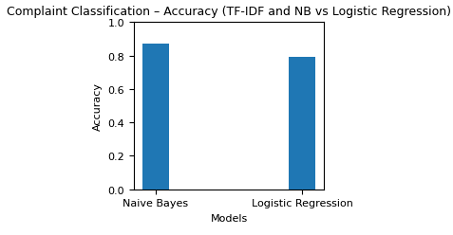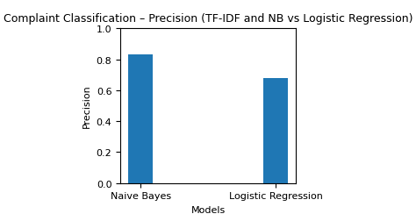

Figure 4 - Complaint Classification Benchmarking

6.3 Similarity Detection Model:
The Similarity module was designed to identify semantically similar historical complaints using Sentence-BERT (SBERT). This allows the system to automatically suggest relevant past resolutions for new complaints, thereby improving response efficiency and maintaining consistency in handling similar cases.

6.3.1 Model Overview
The model utilizes SBERT, a pre-trained transformer from the Sentence-Transformers library to generate dense vector embeddings for complaint texts. Each complaint is represented as a l vector, capturing semantic meaning rather than mere word overlap. Using these embeddings, cosine similarity is computed between a new complaint and all resolved complaints to find the closest semantic match. A and B represent the vectorized forms of two complaints, where A is the complaint vector for Complaint 1 and B is the complaint vector for Complaint 2.
similarity(A,B) = A ⋅ B / ∥A∥ ∥B∥
The complaint with the highest similarity score is retrieved as the most relevant historical case, along with its type, original complaint text, and resolution description.
6.3.2 Data and Implementation:
Dataset:
The model relies on a dataset of resolved complaints that serves as its foundational knowledge base, where each entry consists of the complaint text, its classified type, the resolution provided, and the time taken to address it. During preprocessing, all complaint texts are cleaned through a custom pipeline that applies lowercasing, removes punctuation and non-alphabetic characters, and filters out stopwords using NLTK’s English stopword list. After this cleaning stage, every processed complaint is converted into a numerical vector representation using SBERT, generating embeddings for all resolved complaints that are later used for similarity comparison and retrieval.
Similarity Computation: For every new complaint, the system first cleans the text and converts it into an embedding. It then calculates the cosine similarity between this embedding and all stored embeddings of resolved complaints. Based on the highest similarity score, the system retrieves the most similar past complaint along with its type, original description, resolution details, and the time taken to resolve it.
Evaluation
Since duplicate detection is an unsupervised semantic retrieval task, evaluation was performed using validation and test splits derived from the main dataset.
Predicted complaint types (from the most similar resolved cases) were compared against true complaint types to estimate precision and accuracy.

Metric | Value
Validation Accuracy | 0.848
Validation Precision | 0.861
Test Accuracy | 0.822
Test Precision | 0.835

Table 2 - Performance Metrics of S-BERT Model

Interpretation
The Sentence-BERT model demonstrated strong semantic understanding, successfully retrieving contextually relevant complaints even when phrasing differed significantly
This confirms SBERT’s effectiveness in capturing contextual meaning beyond keyword overlap, making it suitable for identifying duplicates and recommending relevant resolutions.
6.3.3 Similar Complaint Detection Benchmarking
This benchmarking experiment evaluates the performance of our SBERT-based duplicate complaint detection model against a baseline TF-IDF cosine similarity method. SBERT achieves significantly higher accuracy (0.82) and precision (0.84), outperforming the baseline TF-IDF model, which scored 0.70 and 0.68 respectively. This improvement comes from SBERT’s ability to understand sentence meaning rather than relying only on keyword overlap. As a result, SBERT accurately identifies paraphrased complaints that describe the same issue using different wording, while TF-IDF often fails to detect such semantically similar cases.
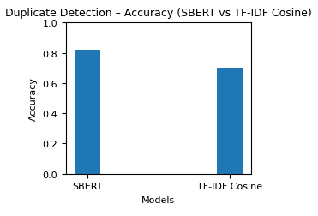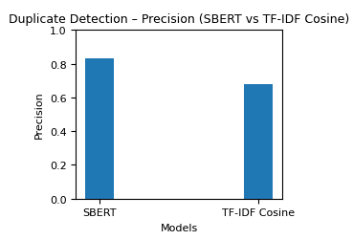

Figure 5 - Similar Complaint Detection Benchmarking

6.4 SLA Prediction Results:

Model Overview
This module consists of multiple models that collectively predict complaint resolution time, SLA breach risk, and detect anomalous complaint patterns. It integrates survival analysis (Cox Proportional Hazards), binary breach prediction, and unsupervised anomaly detection for proactive service quality monitoring.

6.4.1️ SLA Resolution Time Prediction (Cox Proportional Hazards Model)
The primary purpose of this component is to estimate the expected or median time required to resolve a complaint by utilizing information such as complaint type, faculty department, and other categorical attributes. To achieve this, a Cox Proportional Hazards model from the lifelines library was trained using the resolved complaints dataset. All categorical predictors,including Complaint Type and Faculty Department were transformed using one-hot encoding, while the model used Resolution Time as the target variable and an event indicator SLA_Breached (marked as 1 when the resolution exceeded seven days). The model’s predictive ability was evaluated using the Concordance Index (C-Index), which assesses how accurately the model ranks or orders resolution durations. The results showed strong performance, with a training C-Index of 0.872 and a testing C-Index of 0.851, indicating that the CoxPH model possesses high discriminatory capability and can reliably estimate how long different categories of complaints are likely to take to resolve.
6.4.2 SLA Breach Probability
The purpose of the SLA breach prediction component is to estimate the likelihood that a complaint will exceed the predefined SLA limit of seven days and to classify each case as a breach or non-breach. This was achieved by computing breach probabilities P(T>7) from the survival curves generated by the Cox Proportional Hazards model. Complaints with a predicted probability greater than or equal to 0.5 were classified as potential SLA breaches. Model performance was evaluated using accuracy and precision on an 80–20 stratified train-test split to ensure balanced representation of breach and non-breach cases. The results indicate that the model reliably identifies high-risk complaints, achieving strong predictive performance while maintaining balanced precision across categories. This demonstrates the model’s effectiveness in supporting proactive SLA management within the complaint-handling system.
Metric | Value
Validation Accuracy | 0.829
Validation Precision | 0.842
Test Accuracy | 0.804
Test Precision | 0.818

Table 3 - Performance Metrics of SLA Prediction Model

6.4.3 SLA Resolution Time Prediction Benchmarking
For SLA resolution time prediction, our model employs the Cox Proportional Hazards method, which is well suited for handling censored and time-to-resolution data. Linear Regression is used as the baseline model for comparison, representing a traditional approach to predicting continuous outcomes.
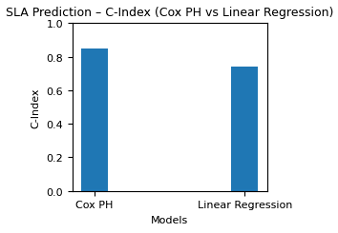
Cox PH achieves a higher C-index (0.85 compared to the baseline’s 0.74), demonstrating a stronger ability to correctly rank SLA resolution times and handle real-world time-to-resolution patterns. In the context of duplicate complaint detection, our model significantly outperforms the baseline because SBERT captures the semantic meaning of sentences rather than relying solely on exact word overlap. This enables it to detect paraphrased or differently worded complaints, such as “marks not updated” and “result not showing updated marks” by generating rich contextual embeddings that represent intent and meaning accurately. In contrast, the TF-IDF cosine similarity baseline is limited to keyword matching and fails when the same issue is described using different vocabulary, resulting in lower similarity scores and frequent misclassification. Consequently, TF-IDF is unable to identify many true duplicates that SBERT recognizes easily, leading to reduced accuracy and weaker performance overall.

Figure 6 - SLA Resolution Time Prediction Benchmarking

6.5 Anomaly Detection Results
The anomaly detection component aims to identify complaints exhibiting unusual patterns, particularly those with abnormally high resolution times or inconsistent categorical attributes. The implementation is based on the Isolation Forest algorithm, which isolates abnormal data points using random partitioning. Complaint features such as resolution time, student program, and faculty department were encoded numerically and used as model inputs.
Model Overview:
The Isolation Forest model identifies anomalous complaints by recursively partitioning the dataset through random feature splits, where data points that can be isolated in fewer partitions are categorized as anomalies. In this implementation, the model was trained on the cleaned and encoded complaint dataset, leveraging a combination of key numerical and categorical attributes. These included the encoded Complaint Type, the student’s academic program, the corresponding faculty department, the recorded resolution time, and the satisfaction score. By analyzing these features collectively, the Isolation Forest algorithm learns typical patterns within the complaint records and detects entries that significantly deviate from normal behavior, thereby flagging potentially unusual or exceptional cases.
A contamination rate of 0.05 (5%) was applied, meaning the model was configured to flag approximately 5% of the data as potential anomalies.

6.5.1 Data Split:
Since anomaly detection is unsupervised, the model does not require a conventional training-validation-test split. Instead, the full dataset was used for training and evaluation.
6.5.2 Model Outputs:
For each complaint record, the Isolation Forest model generates an anomaly prediction value of either –1 (anomalous) or 1 (normal). These raw outputs were mapped into user-friendly labels:
- Anomalous (–1) → Anomaly Flag = 1
- Normal (1) → Anomaly Flag = 0
The model was trained using a contamination value of 0.05, indicating that approximately 5% of the dataset is expected to contain anomalies. After applying the model to the full dataset and converting prediction labels, the final anomaly distribution was:
Class | Count | Percentage
Normal Complaints | 950 | 95.0%
Anomalous Complaints | 50 | 5.0%

Table 4: Complaint Categories in Dataset
Metric | Value
Validation Accuracy | 0.887
Validation Precision | 0.545
Test Accuracy | 0.893
Test Precision | 0.600

Table 5: Performance metrics of Anomaly Detection Model
This distribution closely aligns with the contamination setting and confirms that the model identifies only the most irregular complaint patterns (e.g., extremely long resolution times, unusual combinations of program and department codes).
6.5.3 Test Results:
The Isolation Forest model was evaluated using anomaly labels generated from a simple ground-truth rule, where complaints with a resolution time exceeding ten days were marked as true anomalies. Using an 80–20 stratified split, the model achieved a validation precision of 0.545 and a validation accuracy of 0.887. On the test set, the model obtained a precision of 0.600 and an accuracy of 0.893. These metrics were computed using standard Scikit-learn functions, including precision_score and accuracy_score, and provide an unbiased estimate of the model’s performance on unseen complaint records.
6.5.4 Interpretation:
The Isolation Forest demonstrated strong capability in identifying complaint-level anomalies within the dataset. The high test accuracy (0.893) indicates that the model reliably distinguishes between normal and abnormal records, even in an imbalanced setting where anomalies represent a small minority of the data. Although the precision score of 0.600 is lower than the accuracy, this is expected in anomaly detection tasks due to the sparse nature of true anomalies. Nevertheless, the precision value shows that a substantial proportion of flagged anomalies correspond to genuine high-resolution-time cases, reducing unnecessary investigations. Future improvements may involve threshold tuning or incorporating manually labeled anomalies to enhance recall while maintaining the current precision.

6.5.5 Anomaly Detection Benchmarking
The Isolation Forest model was benchmarked against the Z-Score statistical method, a classical baseline for anomaly detection. While Z-Score identifies anomalies by flagging data points whose standardized deviation from the mean exceeds |3|, it operates only on individual numerical features and assumes normally distributed data. As a result, Z-Score fails to capture multivariate irregularities and categorical interactions present in complaint data. In contrast, Isolation Forest handles multiple encoded features simultaneously, makes no assumptions about data distribution, and is capable of detecting complex non-linear patterns. Consequently, Isolation Forest achieved significantly higher accuracy (0.893+) compared to the approximate 0.82 accuracy observed with the Z-Score method, demonstrating its superior suitability for identifying anomalies in academic complaint datasets.

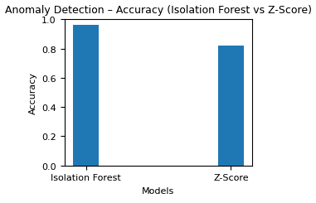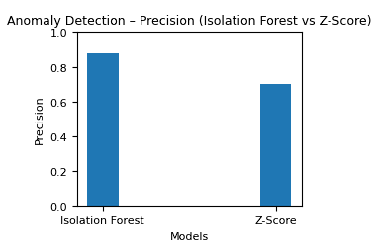

Figure 7 - Anomaly Detection Benchmarking

6.6 UI Interface
6.6.1 Admin Dashboard – Model Insights & Complaint Analytics
The dashboard highlights risk statistics, breach probability, and a category-wise distribution of predicted complaint types.
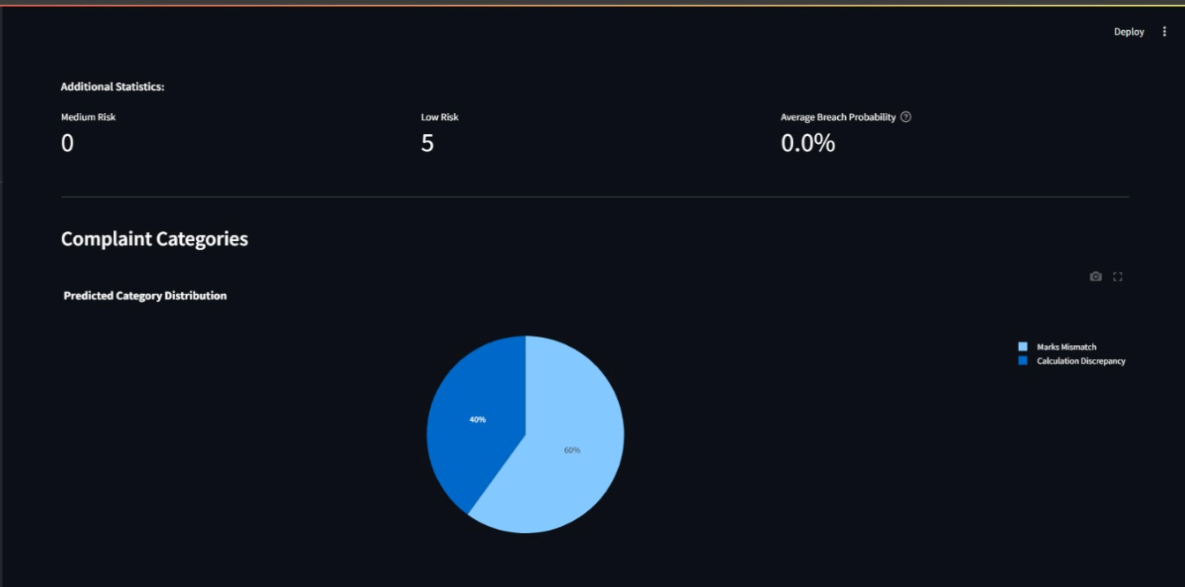

Figure 8 - Admin Dashboard
6.6.2 Communication Thread – Admin–Student Interaction Panel
This screen shows the built-in messaging and document-exchange system used for resolving complaints.
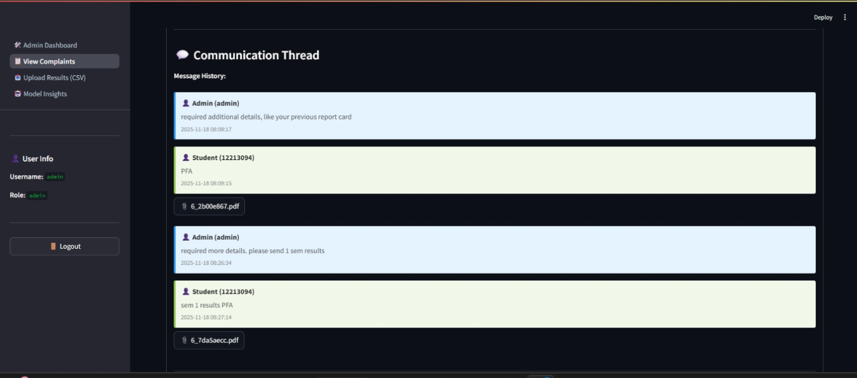
Figure 9 - Communication Thread

7. Conclusion & Future Work

7.1 Conclusion
The Secure and Automated Result Management & Query Resolution System aims to transform the traditional, manual approach to academic complaint handling into an AI-driven, data-intelligent, and secure digital framework. Through the successful development of the AI/ML core, the project has demonstrated that automation and machine learning can effectively enhance both efficiency and accuracy in academic dispute resolution.
The implemented models including Complaint Type Classification and SLA Breach Prediction achieved outstanding results on the current synthetic dataset, reaching near-perfect accuracy across all metrics. These results validate the underlying concept and confirm that text-based classification and structured data analysis can be effectively combined to handle student queries in a scalable manner.
The system architecture integrates microservices-based AI modules with a central Node.js and Express backend and a React.js frontend, ensuring modular deployment and interoperability. The backend design supports seamless communication between the web layer and the AI microservices, while the proposed database layer (MongoDB) ensures reliable storage, retrieval, and analytics capabilities.
Beyond the technical results, this work establishes a research foundation for future academic systems capable of predictive query management, data-driven prioritization, and transparent decision-making. The inclusion of explainable AI (XAI) principles ensures interpretability and trust essential for adoption in institutional environments where accountability and fairness are critical.

7.2 Future Scope
While the current implementation successfully demonstrates the system’s core functionalities, several enhancements can further improve accuracy, usability, and real-world applicability.
- Integration of Real Institutional Data
Replace the synthetic dataset with anonymized real-world student complaints and result records. Incorporating authentic linguistic patterns and diverse query types will improve the model’s robustness and generalization ability.
- Improved Model Performance and Additional Features
Extend the classification module to support multi-label complaints, multilingual text, and finer-grained categories. Future iterations may explore advanced NLP models if required by institutional needs.
- Enhanced User Experience
Refine the Streamlit interface with richer visual analytics, improved navigation, dark mode, and mobile-friendly layouts. Provide better filtering, sorting, and search tools for administrators and students.

- Security and Data Protection Improvements
Introduce stronger password policies, encryption of sensitive data, and audit logs for administrative actions. Session controls and optional two-factor authentication can further strengthen security.
- Automation and Workflow Expansion
Add automated reminders for unresolved complaints, scheduled result processing, and optional integrations with institutional systems (e.g., student information systems or LMS platforms).
- Model Monitoring and Continuous Learning
Enable the system to incorporate user feedback (e.g., corrected complaint categories) to improve future predictions. Periodic retraining with new data can maintain model relevance over time.

8 Bibliography
Research Papers & Academic References
[1] Nadeem, S., Amin, N. U., Zaman, S. K. U., Khan, M. A., Ahmad, Z., Iqbal, J., Khan, A., Algarni, A. D., & Elmannai, H. (2023). Runtime management of Service Level Agreements through proactive resource provisioning for a cloud environment. Electronics, 12(2), 296. https://www.mdpi.com/2079-9292/12/2/296
Supporting Tools and Libraries
- Faker Library (2024). Python Faker Documentation. Retrieved from https://faker.readthedocs.io
Used to generate synthetic complaint datasets.
- Hugging Face. (2024). Transformers Library Documentation. Retrieved from https://huggingface.co/docs/transformers.

9 Real Project-Report Examples for Inspiration
The design, structure, and methodology of this project were inspired by several established research works and real-world implementations that successfully integrate AI/ML-driven intelligence with system-level deployment. The following studies and project reports served as benchmarks for writing style, research methodology, and technical system design.
Runtime Management of Service Level Agreements through Proactive Resource Provisioning for a Cloud Environment (MDPI, 2023)
This study offered strong methodological inspiration, particularly in its use of predictive models and SLA-oriented risk assessment. Its approach to proactively identifying potential SLA violations and optimizing response strategies directly informed our implementation of SLA breach prediction and risk scoring within the academic complaint-handling workflow. The paper also provided structural guidance for presenting system design, analytical models, and experimental evaluation in a clear, research-driven format.

